|  |  |
| --- | --- |
|  |  |
|  | Basic Computations Using Ellipsoids  Geospatial reference systems, Winter Semester 2023  Yixin Zhou, Chunyang Gao  October 2023 |
|  |  |

# Computation of location dependent radiuses of curvature and different types of latitudes

First, we define an ellipsoid with a and e. Then we can calculate location-dependent radiuses of curvature. What we should pay attention to is that for mean Euler’s radius at latitude, we need two Euler’s radiuses which are calculated according to the azimuth from point 1 to point 2 and from point 2 and point 1.

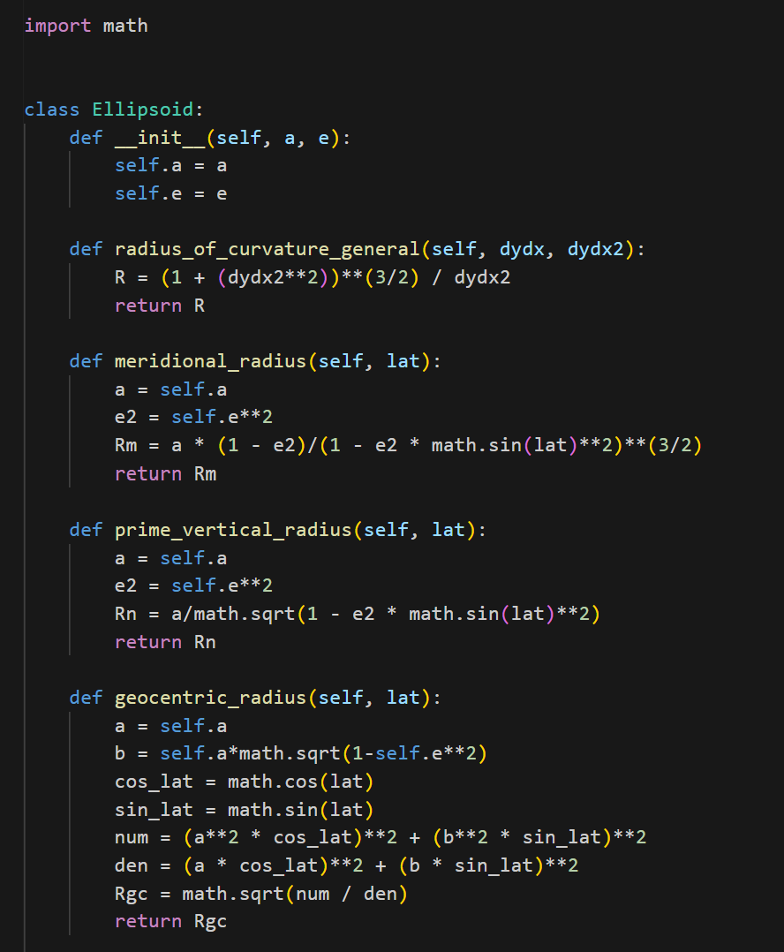 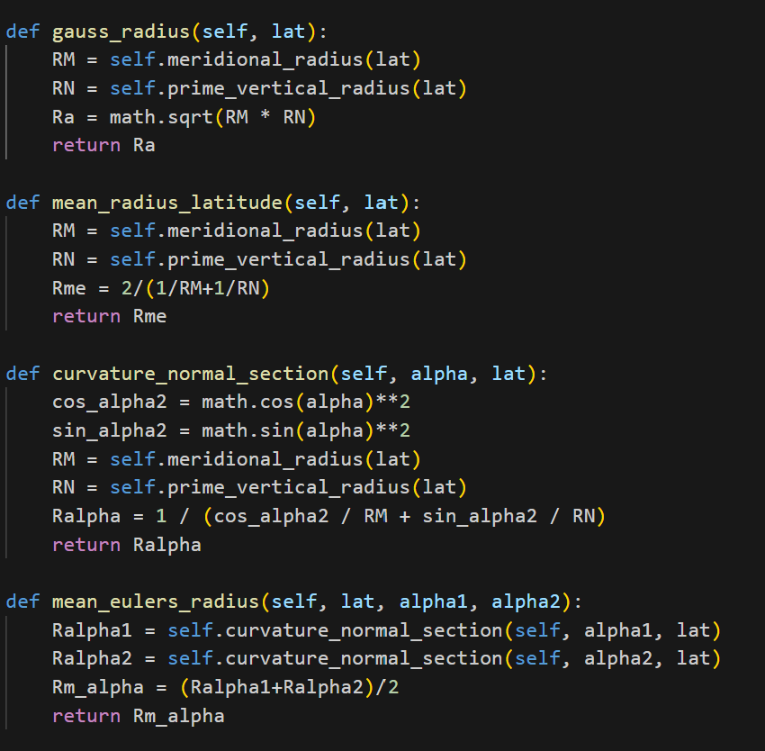

For calculation of different latitudes, we notice that reduced latitude is different from geodetic latitude. It is an angle from the center of the earth to a circle that has the semi-major axis length. Geocentric latitude is defined as the angle between the line connecting a point on the Earth's surface to the center of the Earth and the plane of the Earth's equator.

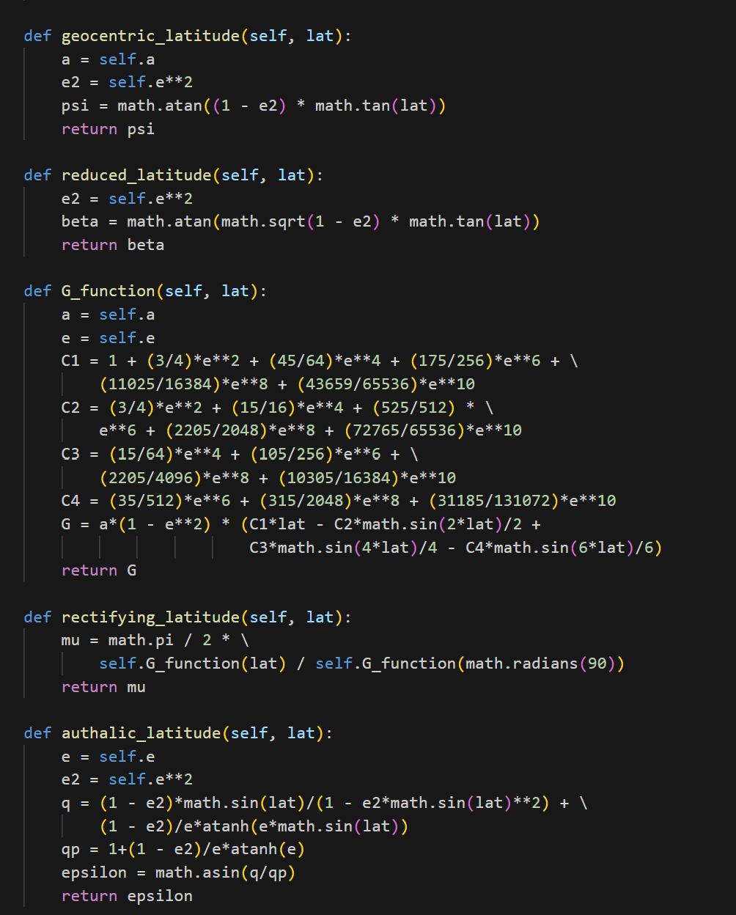

# Conversion between geodetic and Cartesian coordinates ϕ, λ, h ←→ X, Y, Z

To convert geodetic coordinates to Cartesian coordinates, we can calculate directly according to the formula.

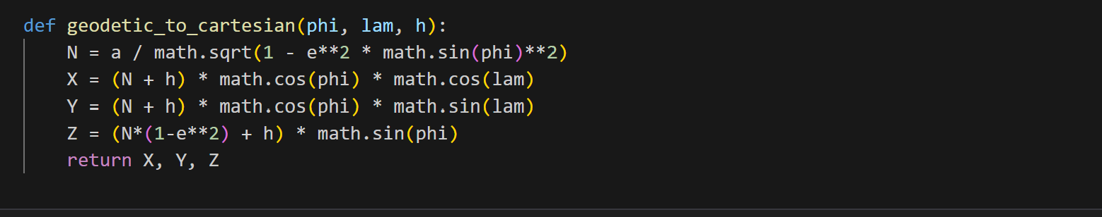

To convert Cartesian coordinates to geodetic coordinates, we first set h to 0 and calculate φ, RN. Then we iterate to calculate h and φ until the solution converges. Latitude can be obtained simply according to the formula.

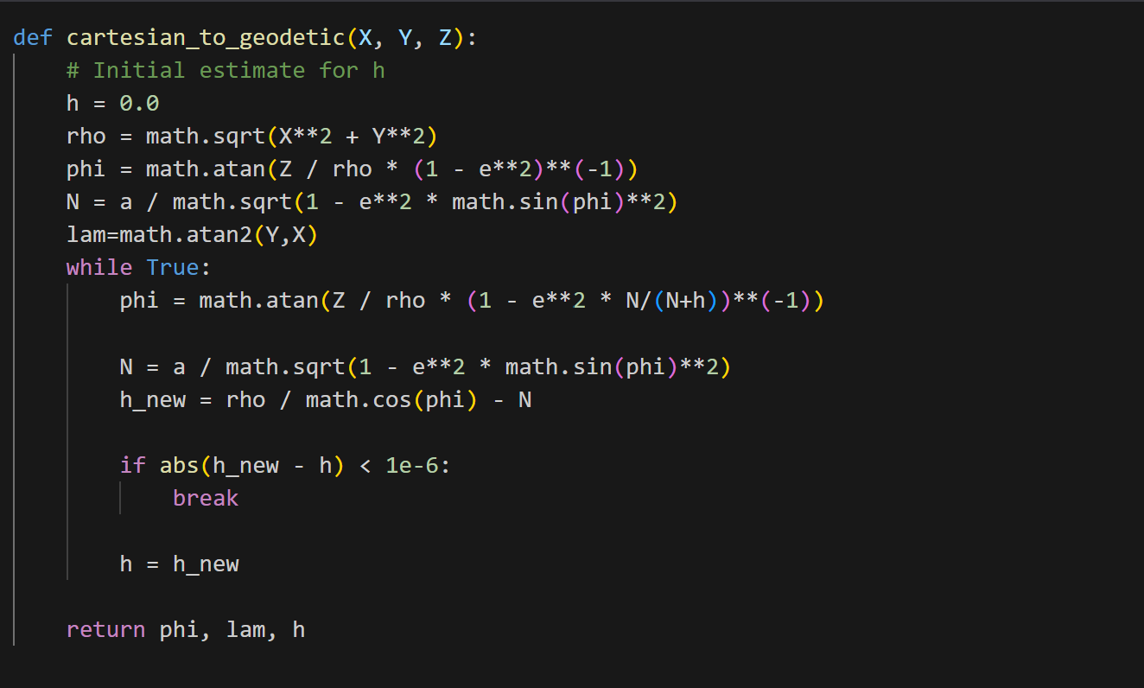

The result shows when converting back to geodetic coordinates, the result contains some error.

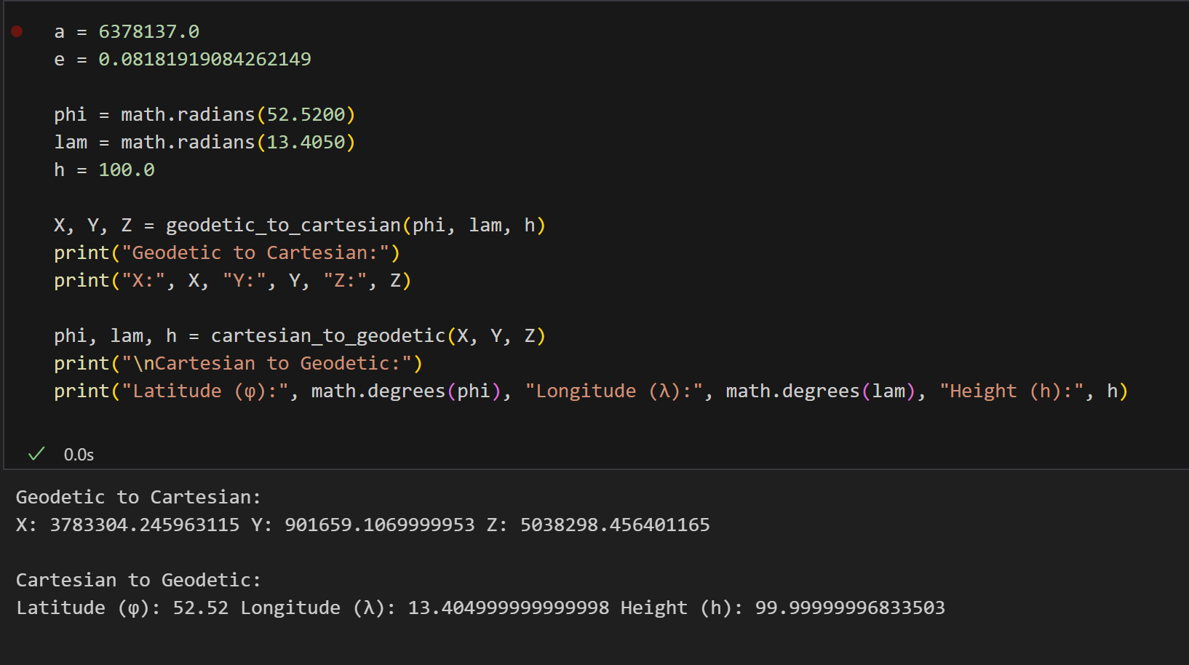

# Forward and inverse geodetic tasks on the ellipsoid

Forward geodetic task: Knowing geodetic coordinates of the first point (ϕ1 , λ1 ), length of the geodetic line s, azimuths between the points α12, the major and minor semi-axes of the ellipsoid a and b, we can calculte geodetic coordinates of the second point (ϕ2 , λ2 ) and α21.

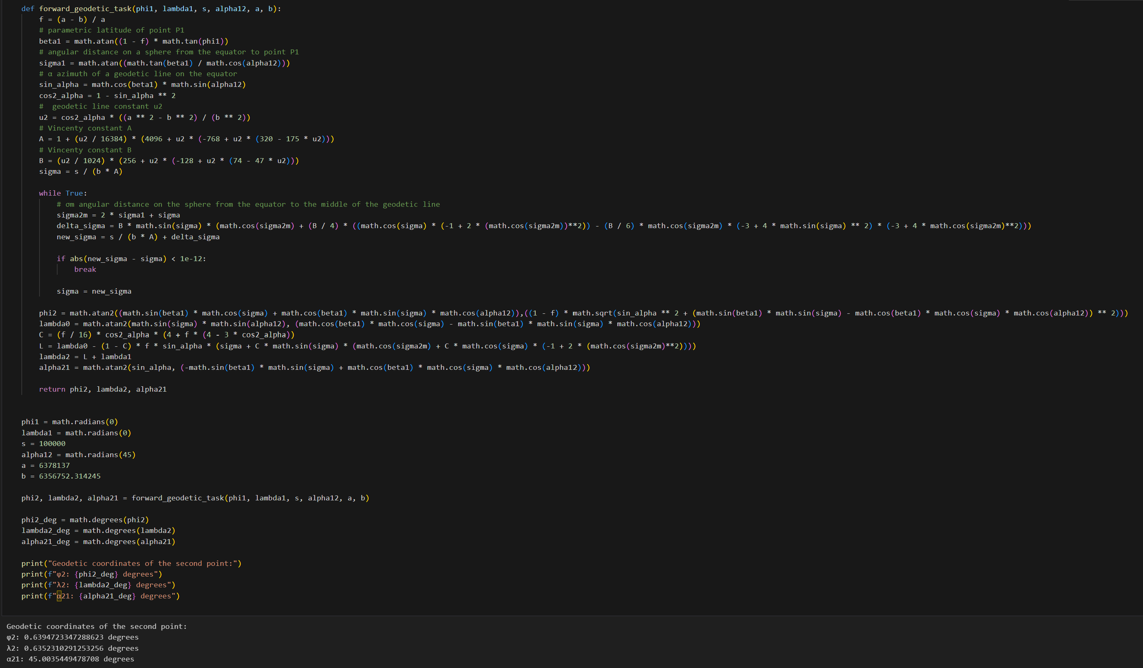

Inverse geodetic problem: Knowing geodetic coordinates (ϕ1 , λ1 ) and (ϕ2 , λ2 ), semi-major and semi-minor axis, a and b, we can calculate length of the geodetic line s and azimuths between points α12 and α21.

